COMPANY PROFILE

Concept Engineers

Civil, Electrical & Electro-Mechanical Engineering Contractor
Dhaka, Bangladesh

Table of Contents
- Introduction
- Objective
- Message from the Managing Director
- Company Information
- Legal & Statutory Details
- Company Overview
- Scope of Services
- Key Personnel Diagram
- Name of Principal Executives
- Work Experience:
- Mission & Vision
- Quality, Health, Safety & Environment
- Client Satisfaction
- Declaration

Introduction
Concept Engineers is a professional engineering and contracting firm in Bangladesh, providing comprehensive Civil, Electrical, and Electro-Mechanical construction services to public and private sector clients. Since its establishment, the company has been committed to delivering quality-driven, cost-effective, and timely solutions in compliance with applicable standards and client requirements.

The company possesses proven experience in executing civil works such as building construction, structural works, foundations, finishing works, and associated infrastructure, alongside electrical and electro-mechanical systems. Our project portfolio includes commercial and office buildings, industrial and manufacturing facilities, garments and textile factories, pharmaceutical plants, hospitals, educational institutions, residential complexes, hotels, and facilities for international organizations.

Concept Engineer’s operates with a skilled team of civil engineers, electrical engineers, project managers, and technical staff who ensure effective planning, coordination, quality control, and safety management throughout the project lifecycle. By integrating civil construction with electrical and electro-mechanical disciplines, the company provides coordinated and efficient project execution.

Driven by professionalism, integrity, and continuous improvement, Concept Engineers strives to build long-term partnerships with clients, consultants, and stakeholders while contributing to the sustainable development of Bangladesh’s construction and engineering sector.

Objective:
  - To deliver quality civil, electrical, and electro-mechanical construction works in compliance with client requirements, applicable codes, and standards, ensuring timely completion, cost efficiency, and effective utilization of manpower, materials, equipment, and financial resources.

  - To achieve sustainable growth through professionalism, safety, and continuous improvement, by maintaining strong relationships with clients, consultants, suppliers, and partners, while adopting modern construction technologies and best industry practices.

Message from the Managing Director
It gives me great pleasure to welcome you to Concept Engineers.

Since our establishment, we have been committed to delivering reliable, high-quality engineering and construction services through professionalism, technical expertise, and ethical business practices. As a mid-level engineering company, we have steadily grown by focusing on client satisfaction, timely project delivery, and strict adherence to quality and safety standards.

Our strength lies in our dedicated team of engineers, managers, and skilled workforce who work with a shared vision to meet the diverse requirements of our clients. We believe in building long- term relationships based on trust, transparency, and mutual respect with our clients, consultants, suppliers, and partners.

At Concept Engineer’s, we continuously strive to improve our capabilities by adopting modern technologies, improving management systems, and developing our human resources. We remain committed to contributing positively to the development of infrastructure and engineering services in Bangladesh.

I sincerely thank our clients and stakeholders for their continued confidence and support, and I look forward to building a successful and sustainable future together.

Engr. Md. Khairul Islam Managing Director Concept Engineers

Company Information

- Name of Company: Concept Engineers
- Year of Establishment: 2016
- Status of the Company: Private Company
- Business type: 1st Class Contractor & Supplier

- Address of Registered Business: Uttara

- Business Address: Ground Floor, H# 94, Ground Floor, R# 02, Mohammadi Hosing Society, Mohammadpur, Dhaka.

- Email: contact.concept.bd@gmail.com

- Email: conceptengineersbd@gmail.com

- Website: www.conceptengineersbd.com

Legal & Statutory Details

  - Valid Trade License: TRAD/DNCC/120905/2022
  - VAT Registration No.: 19121046008

  - Tax Registration Number: BA-156698
  - Registration Number Under the Companies Act 1983 of Dhaka City Corporation Ordinance 0144737: Date of registration: 29-02-2016
  - ABC License Number: C 40/9762

  - Registered Supervisor: Md. Khairul Islam, B.Sc. Engineer (Electrical)
  - Supervising License No.: S-44/10860

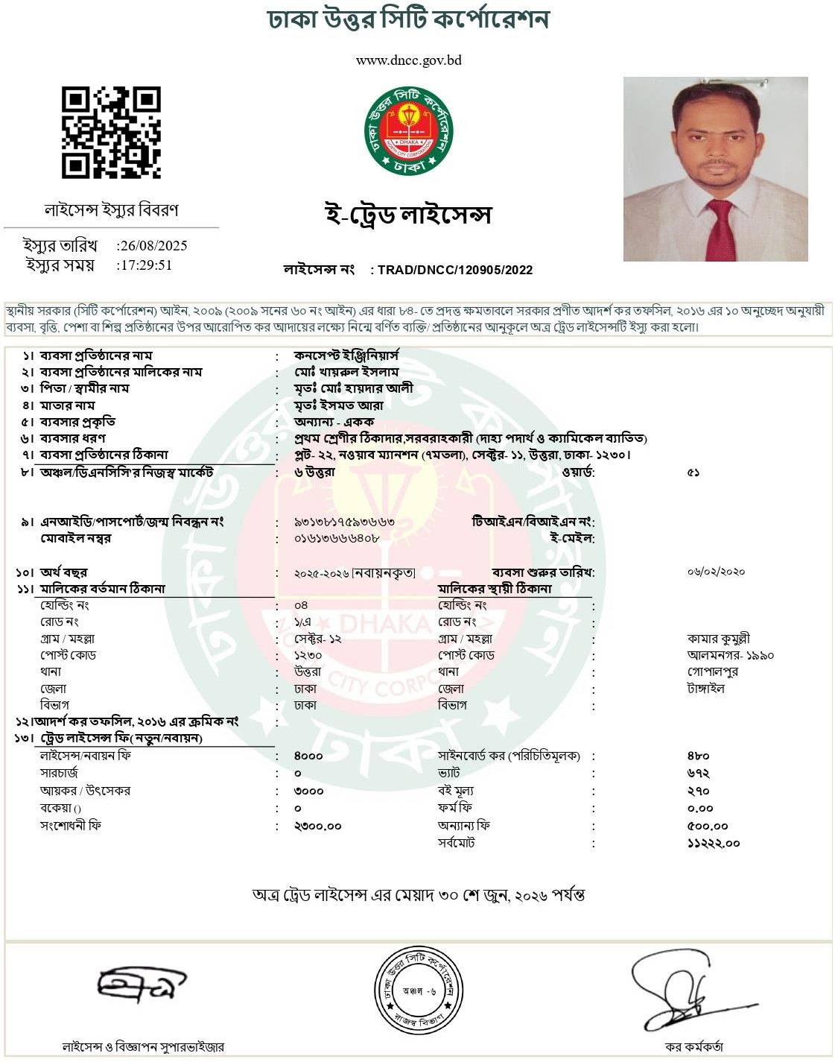

6. 6.

- Company Overview
Concept Engineer’s provides engineering services to industrial, commercial, residential, healthcare, and institutional projects throughout Bangladesh. Light and Heavy Industrial
  - High-Rise Buildings
  - Commercial and Residential Developments
  - Industrial Facilities
  - Garments
  - Pharmaceuticals
  - Dyeing Factories
  - Spinning Mills
  - Office Developments
  - Schools/Colleges & Universities
  - Hospital Installations,
  - Retail Developments
  - Exhibitions
  - Hotels
  - Apartments
  - Restaurants
  - International company & organization
  - Health Centers

7 Scope of Services

- Civil Work
- Sub-station & Generator

- LT/HT Switchgear, MDB, SDB,
- Indoor & Outdoor Lighting Solution
- Lightening Protection System
- Fire Detection & Alarm Systems

- Fire Hydrant System
- Public Address System
- CCTV & Access Control Systems
- Renewable Energy Systems (Solar Energy)
- Plumbing & Building Services & Maintenances

















Key Personnel Diagram
Managing Director
Project Director
Finance Director
Site Manager
Design Engineer Electrical Manager Accounts Manager
Procurement Manager
Civil Engineer
AutoCAD Engineer Electrical Engineer Accounts Officer
Procurement Officer
Civil Supervisors
Electrical Supervisors

- Name of Principal Executives:
Engr. Md. Khairul Islam
B. Sc. Engineer (EEE), | ---------------------- | Managing Director
Engr. Rashid Ahmed
B. Sc. Engineer (Civil) | ---------------------- | Project Director (Civil)
Engr. Md. Tauhid Khan
B. Sc. Engineer (EEE), | ---------------------- | Project Director (Electrical)
Mst Jesmine Akter
M.com | ---------------------- | Finance Director
Md. Zahidul Islam | ---------------------- | Site Manager
B. Sc. Engineer (Civil)
 | ---------------------- | Design Engineer
Rahat Khan
Electrical Engineer | ---------------------- | Electrical Manager
Md. Amirul Islam
B.com. | ---------------------- | Accounts Manager
Md. Amirul Islam | ---------------------- | Procurement & HR Manager
B.com.
MD. Arman | ---------------------- | Civil Engineer
Diploma in Civil
Md. Abu Raihan | ---------------------- | AutoCAD Engineer
Architect
Md. Akram Hossain
Diploma in Electrical Engineer | ---------------------- | Electrical Engineer

- Work Experience:

Supply, Installation & Commissioning of Various Home Appliances-Marine Academy Lot 7

Date of Contract Award | : | 06.11.2.25
Date of Completion | : | 07.12.2025
Employer | : | Commandant  Bangladesh Marine Academy, Sylhet
Location | : | Bangladesh Marine Academy, Sylhet
Contract Value | : | BDT 823500.00
Description of Work | : | Supply, Installation & Commissioning of Various Home Appliances

Supply, Installation of Computer Lab Equipment & Generator-Khandakar Asaduzzaman Academy

Date of Contract Award | : | 27.02.2023
Date of Completion | : | 30.06.2024
Employer | : | Principle, Khandaker Asaduzzaman Academy Gopalpur, Tangail.
Location | : | Gopalpur, Tangail
Contract Value | : | BDT 1816876.00
Description of Work | : | Supply & Installation of Computer with Accessories, Supply & Installation of Multimedia Projector with Screen, Internal Electrical Works, Supply & Installation  Generator, Supply of 48" Television

Project Name: Supply of Electrical, Sanitary, paint items & AC maintenance equipment-Marine Academy Lot 6:

Date of Contract Award | : | 01.10.2024
Date of Completion | : | 07.11.2024
Employer | : | Commandant  Bangladesh Marine Academy, Sylhet
Location | : | Bangladesh Marine Academy, Sylhet
Contract Value | : | BDT 1042550.00
Description of Work | : | Supply of Electrical, Sanitary, paint items & AC

Civil with interior design, Sanitary work. Electrical, Paint, AC Supply & Maintenance of Building at Mohammadpur

Date of Contract Award | : | 01-07-2024
Date of Completion | : | 31-12-2024
Employer | : | Jass Builders & Engineers
Location | : | Mohammadpur, Dhaka
Contract Value | : | BDT 5362129.00
Description of Work | : | Civil with interior design, Sanitary work. Electrical, Paint, AC Supply & Maintenance of  Building.

Civil with interior design, Sanitary work. Electrical, Paint, AC Supply &
Maintenance of Building at Shantinagar, Dhaka
Date of Contract Award | : | 01-07-2021
Date of Completion | : | 01-02-2023
Employer | : | Techsel Office: 60(7th Floor) Porana Palton, Shantinagor, Dhaka-1217.
Location | : | Shantinagar, Dhaka
Contract Value | : | BDT 123,570.00
Description of Work | : | Civil with interior design, Sanitary work. Electrical, Paint, CCTV & Access Control Systems, AC Supply &  Maintenance of Building.

Maintenance, Renovation and Cleaning Works
Date of Contract Award | : | 01-12-2018
Date of Completion | : | 30-10-2023
Employer | : | Military Attache Office of Royal Embassy of Saudi Arabia in Dhaka.
Location | : | Plot No. 3, Block-1, Madani Avenues, Baridhara, Dhaka- 1212
Contract Value | : | BDT 114,50,000.00
Description of Work | : | Civil with interior design, Sanitary work. Electrical, Paint, AC Supply & Maintenance of Building.

Foundation Work with 5 Storied Building Civil works
Date of Contract Award | : | 15-01-2022
Date of Completion | : | 18-12-2023
Employer | : | Classic Steel
Location | : | Farmgate, Dhaka
Contract Value | : | BDT 105,50,000.00
Description of Work | : | Foundation Work with 5 Storied Building Civil works parts.
Electrical Works 8 Storied Building Project
Date of Contract Award | : | 01-10-2022
Date of Completion | : | 30-06-2024
Employer | : | ABC Construction
Location | : | Bosila, Dhaka
Contract Value | : | BDT 55,50,000.00
Description of Work | : | Electrical Works 8 Storied Building Project
Electrical Works 10 Storied Building Project
Date of Contract Award | : | 01-10-2022
Date of Completion | : | 30-06-2024
Employer | : | ABC Construction
Location | : | Bosila, Dhaka
Contract Value | : | BDT 65,00,000.00
Description of Work | : | Electrical Works 10 Storied Building Project

- Mission & Vision
To provide a level of service that will exceed the expectations of our clients, maintain the highest level of quality and allow our employees the opportunity to grow and prosper. To instill confidence with all parties by professionally managing all aspects of each and every project be it large or small at Concept Engineers.

Aim to supply a high quality and versatile services and products to all our clients, delivering the best value at all times whilst continuing to develop our people skills through advance training opportunities. Make continuous improvements to our services which is a prime factor in our continual success.
Operate an open and honest relationship with all of our clients and this includes joint decisions making processes, agreed objectives and anticipated goals.

- Quality, Health, Safety & Environment
The Concept Engineers team of plays a vital role in transforming project ideas into technically sound and economically viable engineering solutions. From the initial concept stage, the team collaborates closely with clients, architects, planners, and stakeholders to develop optimized designs that meet functional, structural, safety, and sustainability requirements.
The responsibilities of the Concept Engineer’s include:
  - Preliminary design development and feasibility studies
  - Conceptual structural and civil engineering solutions
  - Design optimization for cost, constructability, and schedule efficiency
  - Review of architectural concepts and integration with engineering systems
  - Value engineering and risk assessment at early project stages
  - Compliance with applicable codes, standards, and client specification

- Client Satisfaction
Client satisfaction is achieved through timely Construction work, delivery, quality service, and effective communication.

- Declaration
We hereby declare that the information contained in this profile is true and correct.



